**Guide to install Selenium WebDriver**

[](http://click.linksynergy.com/fs-bin/click?id=bt30QTxEyjA&offerid=323058.45&subid=0&type=4)

In this tutorial, we will install Webdriver (Java only) and Configure Eclipse

**Step 1 - Install Java on your computer**

Download and install the **Java Software Development Kit (JDK)** [here](http://www.oracle.com/technetwork/java/javase/downloads/index.html).

[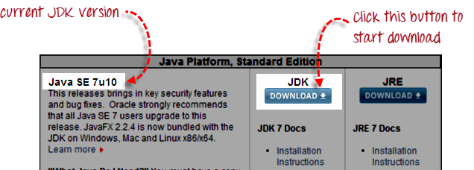](http://cdn.guru99.com/images/install_java_1.png)

Next -

[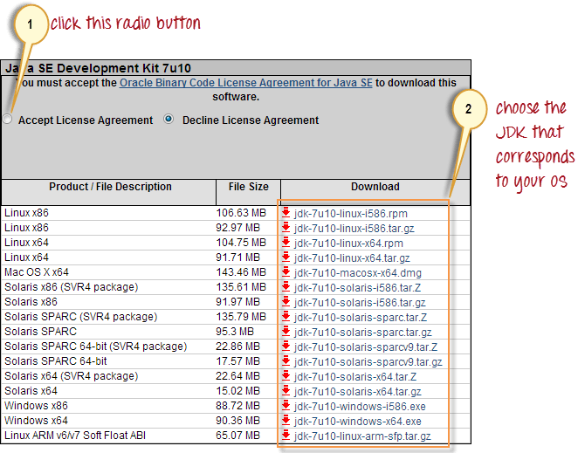](http://cdn.guru99.com/images/install_java_2.png)

This JDK version comes bundled with Java Runtime Environment (JRE) so you do not need to download and install the JRE separately.

**Step 2 - Install Eclipse IDE**

Download "**Eclipse IDE for Java Developers**" [here](http://www.eclipse.org/downloads/). Be sure to choose correctly between Windows 32 Bit and 64 Bit versions.

[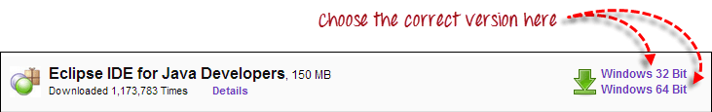](http://cdn.guru99.com/images/install_eclipse_1.png)

You should be able to download a ZIP file named "eclipse-java-juno-SR1-win32-x86_64.zip" (the version number "SR1" may change over time).

[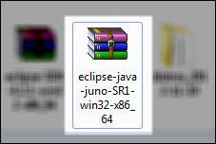](http://cdn.guru99.com/images/install_eclipse_2.jpg)

Inside that ZIP file, there is an "eclipse" folder which contains all the application files. You can extract the "eclipse" folder anywhere you want in your PC; but for this tutorial, extract it to your C drive.

[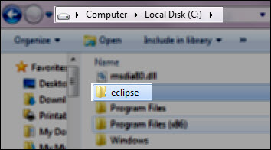](http://cdn.guru99.com/images/install_eclipse_3.jpg)

Unlike other popular software, no installation is required to use eclipse.

**Step 3 - Download the Selenium Java Client Driver**

You can download the **Selenium Java Client Driver** [here](http://seleniumhq.org/download/). You will find client drivers for other languages there, but only choose the one for Java.

[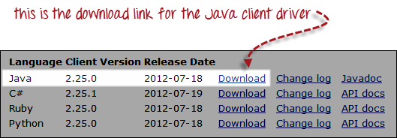](http://cdn.guru99.com/images/download_java_client_driver_1.png)

This download comes as a ZIP file named "selenium-2.25.0.zip". For simplicity, extract the contents of this ZIP file on your C drive so that you would have the directory "C:\selenium-2.25.0\". This directory contains all the JAR files that we would later import on Eclipse.

**Step 4 - Configure Eclipse IDE with WebDriver**

1. Launch the "eclipse.exe" file inside the "eclipse" folder that we extracted in step 2. If you followed step 2 correctly, the executable should be located on C:\eclipse\eclipse.exe.
2. When asked to select for a workspace, just accept the default location.

[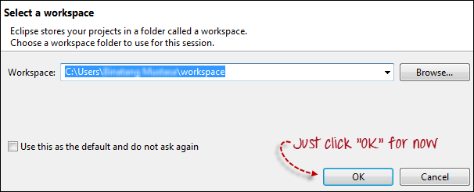](http://cdn.guru99.com/images/configure_eclipse_1b.png)

3. Create a new project through File > New > Java Project. Name the project as "newproject".

[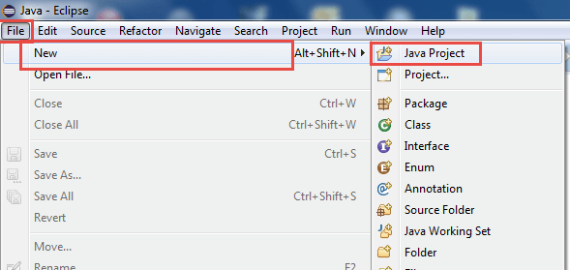](http://cdn.guru99.com/images/cassandra/021316_1152_SeleniumIns1.png)

A new pop-up window will open enter details as follow

1. Project Name
2. Location to save project
3. Select an execution JRE
4. Select layout project option
5. Click on finish button

[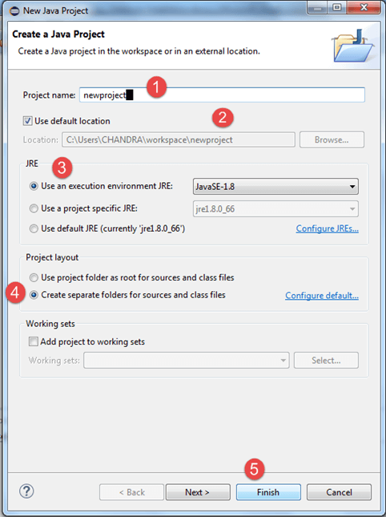](http://cdn.guru99.com/images/cassandra/021316_1152_SeleniumIns2.png)

4. In this step,

1. Right-click on the newly created project and
2. Select New > Package, and name that package as "newpackage".

[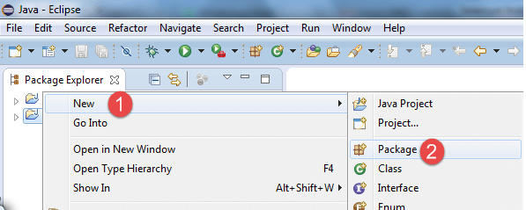](http://cdn.guru99.com/images/cassandra/021316_1152_SeleniumIns3.png)

A pop-up window will open to name the package,

1. Enter the name of the package
2. Click on finish button

[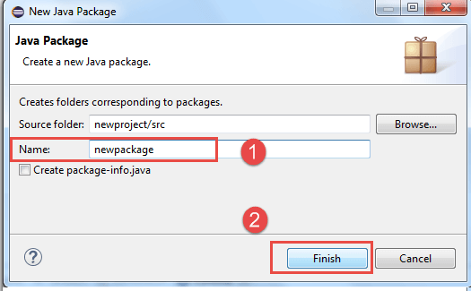](http://cdn.guru99.com/images/cassandra/021316_1152_SeleniumIns4.png)

5. Create a new Java class under newpackage by right-clicking on it and then selecting- New > Class, and then name it as "MyClass". Your Eclipse IDE should look like the image below.

[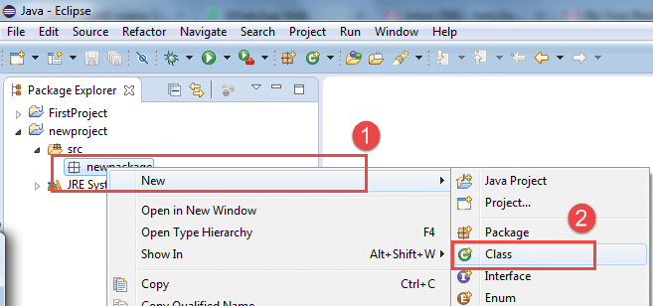](http://cdn.guru99.com/images/cassandra/021316_1152_SeleniumIns5.png)

When you click on Class, a pop-up window will open, enter details as

1. Name of the class
2. Click on Finish button

[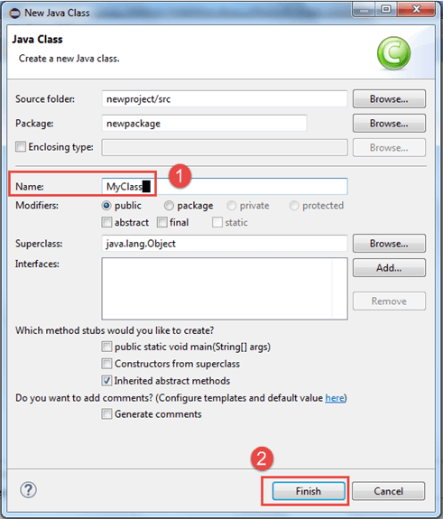](http://cdn.guru99.com/images/cassandra/021316_1152_SeleniumIns6.png)

This is how it looks like after creating class.

[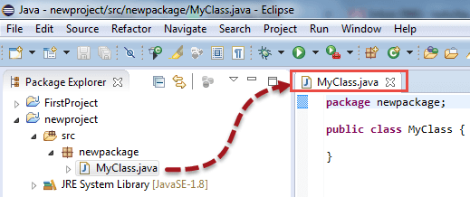](http://cdn.guru99.com/images/cassandra/021316_1152_SeleniumIns7.png)

Now selenium WebDriver's into Java Build Path

In this step,

1. Right-click on "newproject" and select **Properties**.
2. On the Properties dialog, click on "Java Build Path".
3. Click on the **Libraries** tab, and then
4. Click on "Add External JARs.."

[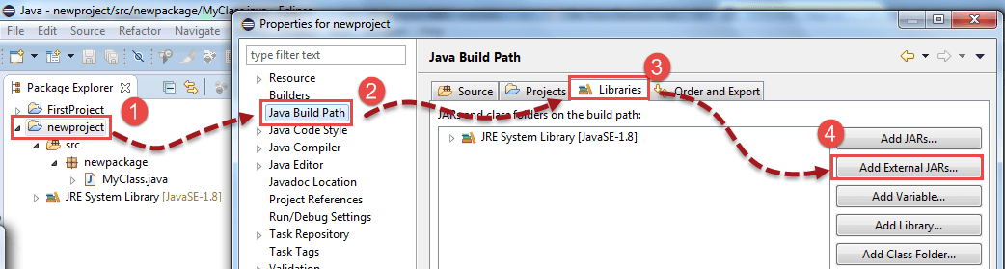](http://cdn.guru99.com/images/cassandra/021316_1152_SeleniumIns8.png)

When you click on "Add External JARs.." It will open a pop-up window. Select the JAR files you want to add.

[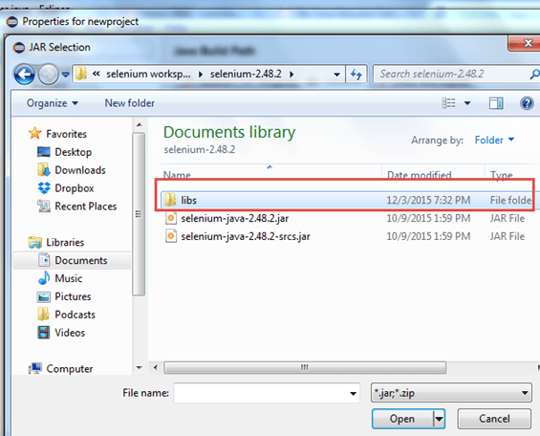](http://cdn.guru99.com/images/cassandra/021316_1152_SeleniumIns9.png)

After selecting jar files, click on OK button.

[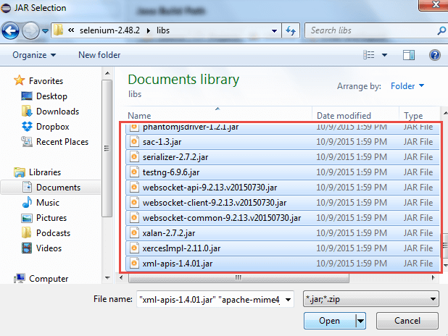](http://cdn.guru99.com/images/cassandra/021316_1152_SeleniumIns10.png)

6. Add all the JAR files inside and outside the "libs" folder. Your Properties dialog should now look similar to the image below.

[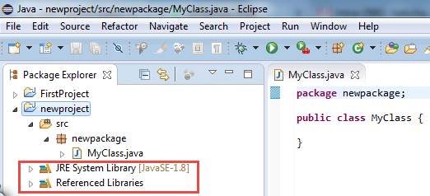](http://cdn.guru99.com/images/cassandra/021316_1152_SeleniumIns11.png)

7. Finally, click OK and we are done importing Selenium libraries into our project.

**Different Drivers**

**HTMLUnit and Firefox are two browsers that WebDriver can directly automate** - meaning that no other separate component is needed to install or run while the test is being executed. For other browsers, a separate program is needed. That program is called as the **Driver Server**.

A driver server is different for each browser. For example, Internet Explorer has its own driver server which you cannot use on other browsers. Below is the list of driver servers and the corresponding browsers that use them.

[](http://click.linksynergy.com/fs-bin/click?id=bt30QTxEyjA&offerid=323058.45&subid=0&type=4)

|  |  |  |
| --- | --- | --- |
| **Browser** | **Name of Driver Server** | **Remarks** |
| HTMLUnit | (none) | WebDriver can drive HTMLUnit without the need of a driver server |
| Firefox | (none) | WebDriver can drive Firefox without the need of a driver server |
| Internet Explorer | Internet Explorer Driver Server | Available in 32 and 64-bit versions. Use the version that corresponds to the architecture of your IE |
| Chrome | ChromeDriver | Though its name is just "ChromeDriver", it is in fact a Driver Server, not just a driver. The current version can support versions higher than Chrome v.21 |
| Opera | OperaDriver | Though its name is just "OperaDriver", it is in fact a Driver Server, not just a driver. |
| PhantomJS | GhostDriver | PhantomJS is another headless browser just like HTMLUnit. |
| Safari | SafariDriver | Though its name is just "SafariDriver", it is in fact a Driver Server, not just a driver. |

You can download these driver servers [here](http://seleniumhq.org/download/)

**Summary**

* Aside from a browser, you will need the following to start using WebDriver
* **Java Development Kit (JDK).** <http://www.oracle.com/technetwork/java/javase/downloads/index.html>
* **Eclipse IDE** - <http://www.eclipse.org/downloads/>
* **Java Client Driver** - <http://seleniumhq.org/download/>
* When starting a WebDriver project in Eclipse, do not forget to import the Java Client Driver files onto your project. These files will constitute your Selenium Library.
* HTMLUnit and Firefox are the only browsers that you can automate without the use of a Driver Server.
* Each other browser has its own driver server.